**PLSQL - PROCEDURE PROGRAM :**

**PROGRAM 1 : PRINT HAI**

SQL> set serveroutput on

SQL> create or replace procedure WELCOME

as

begin

dbms_output.put_line('HAI!');

end;

/

**OUTPUT:**

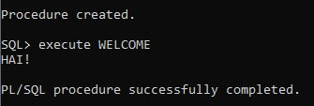

**PROGRAM 2 : PROCEDURE TO INSERT VALUES INTO A TABLE**

SQL> CREATE OR REPLACE PROCEDURE addemp

(depid IN dept.eid%TYPE,

depname IN dept.ename%TYPE,

depsal IN dept.psal%TYPE,

deploc IN dept.ploc%TYPE)

IS

BEGIN

INSERT INTO dept Values(depid,depname,depsal,deploc);

dbms_output.Put_line('dpmt added');

end;

/

**OUTPUT:**

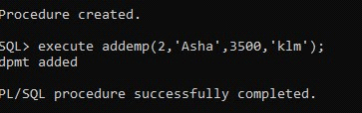

**PROGRAM 3 : DROP A PROCEDURE**

SQL> DROP PROCEDURE WELCOME;

**OUTPUT :**



**PROGRAM 4 : PROCEDURE TO FIND FACTORIAL OF A NUMBER**

SQL> CREATE OR REPLACE PROCEDURE factorial_proc(

num IN NUMBER,

fact OUT NUMBER

AS

result NUMBER := 1;

BEGIN

IF num < 0 THEN

DBMS_OUTPUT.PUT_LINE('Factorial is not defined for negative numbers.');

fact := NULL;

ELSIF num = 0 THEN

fact := 1;

ELSE

FOR i IN 1..num LOOP

result := result * i;

END LOOP;

fact := result;

END IF;

END factorial_proc;

/

Procedure created.

SQL> DECLARE

input_number NUMBER := 5;

result_factorial NUMBER;

BEGIN

factorial_proc(input_number, result_factorial);

DBMS_OUTPUT.PUT_LINE('Factorial of ' || input_number || ' is ' || result_factorial);

END;

/

**OUTPUT :**

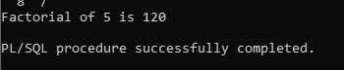

**PROGRAM 5 : PROCEDURE TO FIND SUM OF NUMBERS**

SQL> CREATE OR REPLACE PROCEDURE sum_of_three(

num1 IN NUMBER,

num2 IN NUMBER,

num3 IN NUMBER,

sum_result OUT NUMBER

AS

BEGIN

sum_result := num1 + num2 + num3;

END sum_of_three;

/

Procedure created.

SQL> DECLARE

number1 NUMBER := 5;

number2 NUMBER := 10;

number3 NUMBER := 15;

result_sum NUMBER;

BEGIN

sum_of_three(number1, number2, number3, result_sum);

DBMS_OUTPUT.PUT_LINE('Sum of ' || number1 || ', ' || number2 || ', and ' || number3 || ' is ' || result_sum);

END;

/

**OUTPUT :**

